Hotel Reservation Form
Courtyard by Marriott Suwon
KSOG 2024 staying 4th Nov ~ 11th Nov 2024
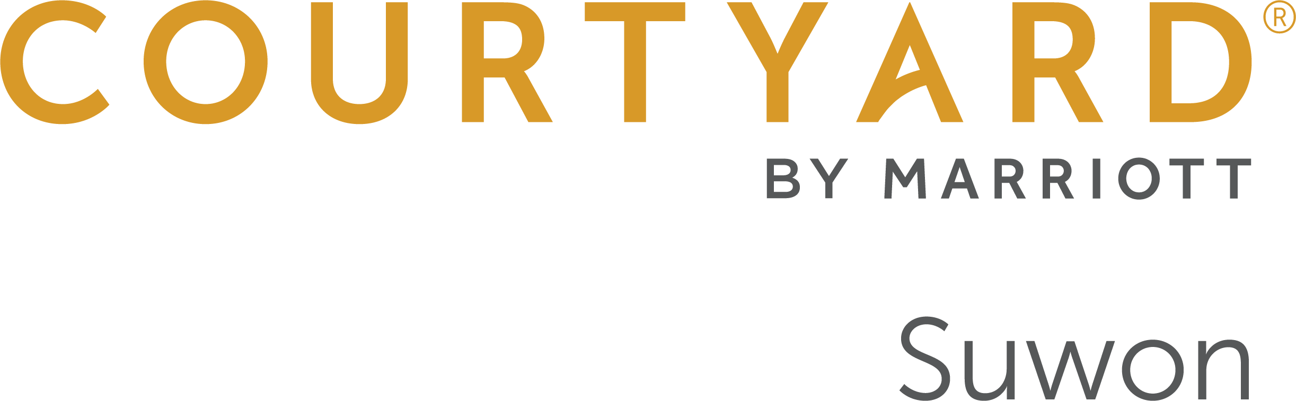

320, Gwanggyohosugongwon-ro, Yeongtong-gu, Suwon, 16514, South Korea
Phone: 82-31-267-6700 / Fax: 82-31-267-5601
For Reservation, Attention to Reservation manager
Please e-mail to cy.selcw.reservation@courtyard.com
Copy to Sarah.park@courtyard.com

Personal Information

Reservation can be made up until 7th October 2024
Mr. / Ms. | Last Name: | Middle Name: | First Name:
Company/Organization: |  | Bonvoy Membership Number:
Work Phone:
Country code Area code Number

E-mail:

Itinerary & Room Reservation
Arrival(MM/DD/YY):  Estimated Arrival Time:  (Check-in: 15:00) | Departure(MM/DD/YY):  (Check out: 12:00)
ROOM RATE
Premier Room (All - Non Smoking rooms)
Room Size : 28㎡
□ Premier King or Double (Room only) KRW 240,000
□ Premier King or Double (1breakfast) KRW 260,000
□ Premier King or Double (2breakfast) KRW 280,000
* Please mark x which you prefer.
* Additional Breakfast charge KRW 45,100 per person on site.
* All rates are Excluded 10% VAT.

General Benefits
* Daily two (2) complimentary bottles of mineral water
* Complimentary use of the gym on 3rd floor
* Free WIFI access at the guest room

* Special request if necessary: | * Special request if necessary:

Please offer your credit card information to guarantee your reservation via E-sertifi link.
(*Link will be provided to insert your credit card information from reservation center via e-mail. Please fill it in the link to guarantee your reservation.)
Cancellation Policy | Cancel request after 7th Oct. 2024, 100% Cancellation Penalty will be charged for the whole stay reserved.
Agreed for providing personal information to hotel | □Yes □No
Signature:

Please complete this form and return it directly to hotel by e-mail.
Contact Person | Phone | Fax | Email
Reservation | 82-31-267-6700 | 82-31-267-5601 | cy.selcw.reservation@courtyard.com

